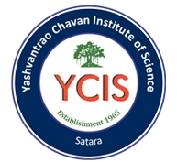
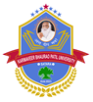

Education through self-help is our motto- Karmaveer
Rayat Shikshan Sanstha’s
Yashavantrao Chavan Institute of Science
(Constituent College Karmaveer Bhaurao Patil University, Satara)
----------------------------------------------------------------------------------------
NAAC Reaccredited at A⁺⁺ Grade with CGPA: 3.61, UGC-CPE-II, DBT-STAR, DST-FIST, RUSA Excellence, UGC-PARAMARSH, ISO: 9001-2015
--------------------------------------------------------------------------------
Department of Microbiology and Dream Foundation, Satara
Jointly organizes
Two Days
International Conference on

“MICROBIOLOGY FOR SUSTAINABLE FUTURE-DEVELOPMENTAL PERSPECTIVES -2026”

(ICMSFDP-2026)
(23rd – 24th January, 2026)
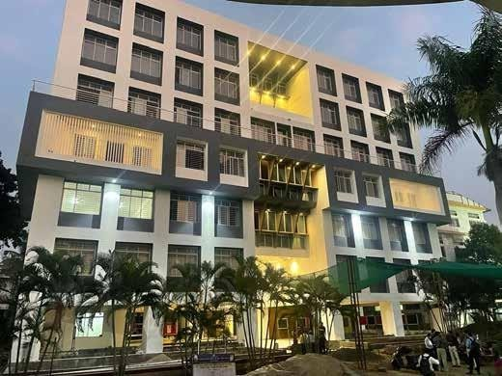
Yashavantrao Chavan Institute of Science,
Karmaveer Bhaurao Patil University, Satara, Maharashtra, India
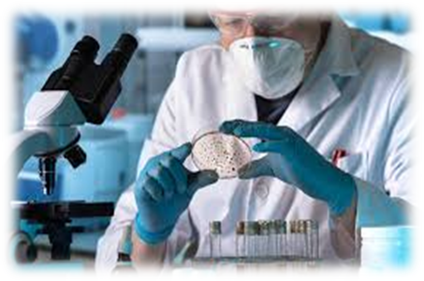
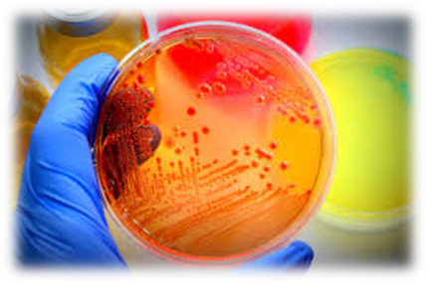
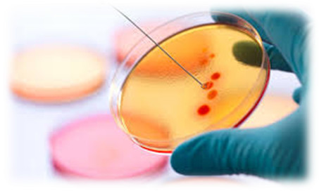

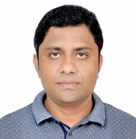
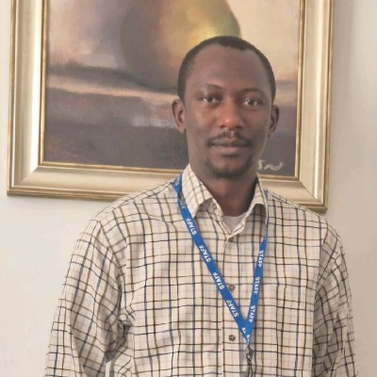
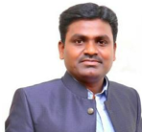
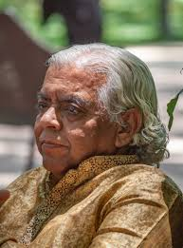
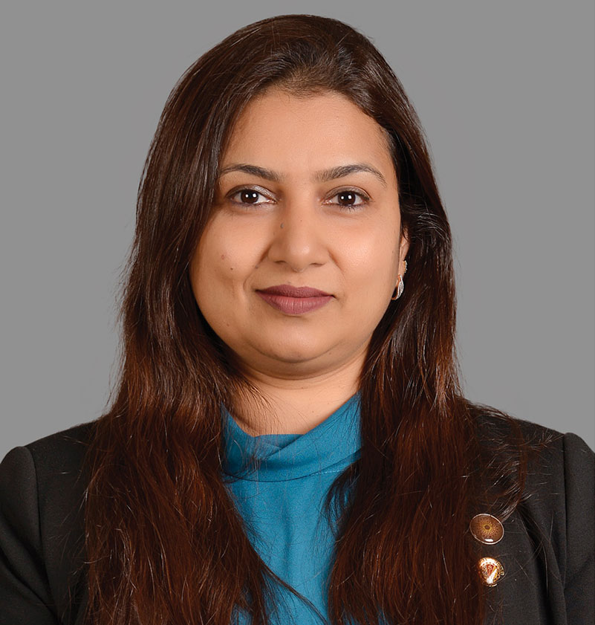
Key Note and Invited Speakers

Dr. S. NAGARAJ
Assistant Professor, University of Madras
DR. APURBA KUMAR SARKAR
Technical Consultant – Bio Growing Company Ltd., Shanghai (Bangladesh operations)
DR. ALIYU IBRAHIM DABAI
Technical Consultant – Bio Growing Company Ltd., Shanghai (Bangladesh operations)
DR. SHARAD KALE
Special Advisor to the Hon. Chief Minister, Goa.

TRUPTI SWARUP GOKHALE
Professor, Department of Biotechnology,
BITS Pilani, Dubai Campus
About Rayat Shikshan Sanstha
Rayat Shikshan Sanstha is one of the largest educational institutions in Asia. It was founded in 1919 by Karmaveer Bhaurao Patil with the noble aim of integrating socially and economically disadvantaged communities into the mainstream through education. In recognition of his immense contribution to the field of education, the Government of India honoured him with the prestigious Padma Bhushan Award. Currently, Rayat Shikshan Santh operates an impressive network of 751 branches, which includes 42 colleges, 441 secondary schools, 7 training colleges, 52 primary schools (24 of which are English-medium), 42 pre-primary schools (28 English-medium), 91 hostels, 7 administrative offices, 8 Ashramshalas, 3 Industrial Training Institutes (ITIs), 52 ancillary branches, and one research institute.
About Organizing Institute

Yashavantrao Chavan Institute of Science, Satara, is a premier institution and the constituent college of Karmaveer Bhaurao Patil University, Satara. It has been reaccredited with an A⁺⁺ grade (CGPA 3.61) by the National Assessment and Accreditation Council (NAAC) in its fourth cycle. The institute has earned numerous accolades, including the College with Potential for Excellence status from the University Grants Commission (UGC), recognition under the star College Scheme by the Department of Biotechnology, and FIST support from the Department of Science and Technology, Government of India. It has also received the Best College Award for its NSS unit from the Government of Maharashtra and Shivaji University, Kolhapur, as well as the Academic Excellence Award and Best College Award from Shivaji University and Rayat Shikshan Sanstha, Satara.
YCIS has been recognized under the RUSA Excellence Program and granted financial assistance under RUSA Component 8. The institute offers undergraduate (UG), postgraduate (PG), and Ph.D. programs in basic sciences and professional courses all under one roof. Its robust research facilities, state-of-the-art infrastructure, student-centric amenities, and scholarships foster an academic and research-oriented culture aimed at developing competent citizens. Recently, the institute established a centre for Invention, Innovation and Incubation with support from RUSA, Tata Technologies Pvt. Ltd., Singapore, and the Science and Technology Park, Pune. The institute also established a Section 8 company named Karmaveer Bhaurao Patil Research Foundation (KBPRF). Presently 3, 761 UG students, 442 PG students from across India (from Kerala to Jammu and Kashmir), and 78 Ph. D. research scholars are pursuing their education at YCIS.
About Satara City

Satara, a historic city and capital of the Maratha Empire, is located in the state of Maharashtra, India. It lies along the Pune-Bengaluru National Highway (NH-48), approximately 110 km from Pune. The city is renowned for its proximity to the Kaas Plateau, a UNESCO World Natural Heritage Site, situated just 22 km away. Satara also serves as a gateway to several other popular destinations, including Mahabaleshwar, Thosegar Waterfalls, Panchgani, and Sajjangad.
About the International Conference

The “International Conference on Microbiology for Sustainable Future: Developmental Perspectives (ICMSFDP-2026)” is organized by the Department of Microbiology to provide an international platform for researchers, academicians, industry experts, policymakers, and students. The conference aims to encourage scientific exchange, innovation, and collaborations across diverse areas of modern Microbiology.
This interdisciplinary event emphasizes the pivotal role of Microbiology in sustainable development. It highlights microbial applications in health, biotechnology, waste management, food systems, and industrial processes essential for building a more sustainable and resilient global society. The conference will explore emerging microbial technologies, cutting-edge research, and strategic solutions that can address pressing global challenges while shaping a sustainable future through Microbiology.

Key Focus Areas
- Artificial Intelligence in Life Sciences
- Advances in Life Sciences for Sustainable Development
- Sustainable Agriculture, Soil Health & Plant Sciences
- Biotechnology & Genetic Engineering for Green Technologies
- Biofertilizers, Biostimulants & Natural Plant Growth Regulators
- Molecular cloning and gene expression
- Bioinformatics, AI & Computational Biology
- Bioremediation & Eco-Restoration Technologies
- Food Science, Nutrition & Food Safety
- Medical Biotechnology & Drug Discovery
- Clinical Diagnostics, Immunology & Disease Biology
- Industrial Biotechnology & Green Manufacturing
- Biomaterials, Biopolymers & Bioplastics
- Microbiome Research Across Ecosystems
- Mycology, Virology & Emerging Pathogens
- Innovations in Life Science
Invitation

We are pleased to invite you to the International Conference on “Microbiology in Sustainable Future: Developmental Perspectives (ICMSFDP-2026),” organized by the Department of Microbiology, Yashavantrao Chavan Institute of Science, Karmaveer Bhaurao Patil University, Satara, Maharashtra, India. This global event brings together researchers, academicians, industry professionals, and policymakers to discuss recent advancements and innovative microbial solutions that support sustainable development.
The conference will highlight key areas such as microbial biotechnology, clinical and environmental microbiology, genomics and bioinformatics, nanotechnology, bioenergy, biopolymers, and eco-friendly microbial materials. ICMSFDP-2026 aims to foster collaboration, encourage cutting-edge research, and promote the vital role of microbiology in addressing global challenges and building a sustainable future.
We look forward to your participation in making ICMSFDP-2026 a meaningful step toward scientific progress and sustainability.
Conference Highlights:
- Keynote lectures by eminent speakers
- Plenary sessions and panel discussions
- Oral and poster presentations
Important Dates:
Abstract submission deadline: 10th January, 2026
Full-length papers: 15th January, 2026
Registration deadline: 15th January, 2026
For more details regarding registration, submission guidelines, and the conference schedule, please visit our website: www.ycis.ac.in
We look forward to your participation and contribution to making this conference a grand success.

Warm regards,

Prof. Dr. G.V. Utekar
Chairperson, ICMSFDP-2026
Head, Department of Microbiology, YCIS, Satara
942203031

Our Patrons

Hon. Shri. Sharadchandraji Pawar
President, Rayat Shikshan Sanstha, Satara

Hon. Shri. Chandrakant Dalavi
Chairman, Rayat Shikshan Sanstha, Satara
Provost, Karmaveer Bhaurao Patil University, Satara

Hon. Dr. Dnyandeo Mhaske
Vice Chancellor, Karmaveer Bhaurao Patil University, Satara

Hon. Dr. Anil Patil
Organizer, Rayat Shikshan Sanstha, Satara

Hon. Shri. Vikas Deshmukh
Secretary, Rayat Shikshan Sanstha, Satara

Hon. Prin. Dr. Shivling Menkudale
Jt. Secretary (H. Edu.), Rayat Shikshan Sanstha, Satara

Hon. Prin. Dr. Rajendra More
Jt. Secretary (Audit), Rayat Shikshan Sanstha, Satara

Organizing Committee

President
Prin. Dr. B. T. Jadhav

Chairperson
Prof. Dr. G. V. Utekar

Convener
Ms. M. M. Raut

Co-Convener
Ms. D.P. Pachhade

Organizing Secretary
Dr. B. S. Pawar

Treasurer
Prof Dr. V. S. Patil

Members

Ms. P. R. Jadhav Ms. P. V. Mali
Mr. A. S. Jadhav Ms. S. R. Inje
Dr. A. A. Survase Ms. P. V. Patil
Ms. S. S. Desai Ms. M. T. Mane
Ms. A. C. Dike Ms. P. R. Salunkhe
Ms. S. M. Mane Mrs. A. R. Jagtap
Ms. D. P. Gholap Ms. P. S. Waydande
Ms. A. B. Bhandirge Ms. K. S. Yadav

International Advisory Committee

Dr Anjana Sing
Professor in Microbiology, Tribhuvan University, Kathamandu, Nepal.
Dr Tripti Gokhale
Professor BITS Pilani Dubai Campus, Dubai.
Dr. Satish B. Jadhav
Department: School of Material Science and Engineering, Yeungnam University, Gyeongsan 38541, Korea.

Dr. Anjana Sing
Professor in Microbiology, Tribhuvan University, Kathmandu, Nepal.
Dr. Tripti Gokhale
Professor, BITS Pilani, Dubai Campus.
Dr. Santosh A. Misal
Scientist, National Institute of Health, USA.

Dr. Gajanan S. Ghodake
Associate Professor, Department of Biological and Environmental Science, Dongguk University-Seoul Goyang, Gyeonggi, South Korea.
Dr. Pradeep Kumar Shah
Associate Professor, Department of Microbiology, Tri-chandra M. Campus, Tribhuvan University, Kathmandu, Nepal.
Dr. Mayur Bharat Kurade
Research Avenue, Bundoora Technical Development Centre, Nuton, Rio Tinto. Bundoora. VIC, Australia 3083.
Dr. Amar Yeware
Cell and Gene therapy Scientist I, Academy of Scientific and Innovative research, UW school of Medicine and Public health Madison, Wisconsin, United States.
Dr. Narendra Sankpal
Assistant Professor, Norton Thoracic Institute, St. Joseph’s Hospital and Medical Center, Phoenix. AZ. USA.
National Advisory Committee

Dr. A. M. Deshmukh
President, Microbiology Society India.
Prof. Dr. H. V. Deshmukh
Secretary, Microbiology Society India.
Prof. Dr. J. P. Jadhav
In-charge Pro-Vice Chancellor and Head of the Department of Biotechnology, Shivaji University, Kolhapur, Maharashtra, India.
Prof. Rup Lal
F(AAM), FNA, FNASc, FNAAS INSA Senior Scientist, Acharya Narendra Dev College, University of Delhi, New Delhi-110019, India.
Prof. T. K. Adhya,
FNA, FNASc, FNAAS, Professor, School of Biotechnology, KIIT University (Deemed), Bhubaneswar - 751024, Odisha.
Dr. Girish R. Pathade
Dean, Krishna Institute of Allied Sciences, Krishna Vishwa Vidyapith, Karad, Maharashtra, India.
Dr. S. S. Nayak
Principal, Karmaveer Bhaurao Patil College, Vashi, Maharashtra, India.
Prof. Dr. R. D. Joshi
Principal & Head Department of Microbiology, Yogeshwari Mahavidyalaya, Ambejogai, Dist- Beed, Maharashtra, India.
Dr. A. R. Jadhav
Principal Miraj Mahavidyalaya, Miraj, Maharashtra, India.
Prof. Dr. Ujjwala S. Patil
Principal, Baba Naik Arts College, Kokrud, Maharashtra, India.
Prof. Dr. Mrs. S. S. Ahiwale
Vice Principal, Mahatma Phule Mahavidyalaya, Pimpri, Pune, Maharashtra, India.
Prof. Dr. Yogini R. Mulay
Vice Principal, Tuljaram Chaturchand College of Arts, Science and Commerce, Baramati. Maharashtra, India.
Dr. M. K. Ranjekar

Technical Director, Green Vitals Biotech, Pune, Maharashtra, India.
Prof. Dr. K.D. Sonawane
Head Department of Biochemistry, Shivaji University, Kolhapur, Maharashtra, India.
Prof. Dr. G. V. Mali
Head, Department of Microbiology, Patangrao Kadam College, Sangaliwadi, Maharashtra, India.

Prof. Dr. P. N. Satwadhar
Ex. Dean Vasantrao Naik Marathwada Agricultural University, Parbhani, Maharashtra, India.
Prof. Dr. Milind H. Gajbhiye
Department of Microbiology, Tuljaram Chaturchand College of Arts, Science and Commerce, Baramati, Pune, Maharashtra, India.
Prof. Dr. S. M. More
Head, Department of Microbiology, Yashwant Mahavidyalaya, Nanded, Maharashtra, India.
Mrs. Sarita M. Wadmare
Head, Department of Microbiology, Willingdon College, Sangli, Maharashtra, India.
Dr. Vishwas S. Patil
Head, Department of Microbiology, L.B.S. College, Satara, Maharashtra, India.
Dr. Girish B. Pendharkar
Head, Department of Microbiology, S.G. M. College, Karad, Maharashtra, India.
Dr. Supriya S. Wankar
Head, Department of Microbiology, Janata Mahavidyalaya, Chandrapur, Maharashtra.
Dr. R. V. Burase
Scientist & Assistant Professor, Alcohol Technology & Biofuels, Vasantdada Sugar Institute, Manjari, Pune, Maharashtra, India.
Dr. Jaysing U. Patil
Head, Department of Microbiology, Yashwantrao Chavan College of Science, Satara, Maharashtra, India.
Ms. Manisha R. Maka
Head, Department of Microbiology, Sangamner Nagarpalika Arts, D. J. Malpani Commerce & B. N. Sarda Science College, Samgamner, Maharashtra, India.
Dr. Pradeep D. Ghumbre
Assistant Professor, Department of Microbiology, Smt. Sindhutai Jadhao Art’s and Science Mahavidyalaya Mehkar, Dist-Buldhana, Maharashtra. Pune.
Mr. Vishnu G. Jadhav
Assistant Professor, Department of Microbiology, Yashwantrao Chavan Arts, Commerce and Science College, Lakhandur, Bhandara, Maharashtra, India.
Local Advisory Committee

Prof. Dr. D. D. Namdas
Vice Principal, YCIS, Satara
Prof. Dr. J. J. Chavan
Vice Principal, YCIS, Satara
Prof. Dr. P. V. Chavan
Dean, PG Studies, YCIS, Satara
Dr. M. L. Ahire
Dean, UG Studies, YCIS, Satara
Dr. S. H. Mujawar
Dean, Research and Development, YCIS, Satara
Dr. A. D. Kadam
Dean, Infrastructure, YCIS, Satara
Dr. G. S. Jadhav
Dean, Diploma and Skill Courses, YCIS, Satara
Dr. P. K. Pagare
Academic Registrar, YCIS, Satara
Dr. D. M. Karanjkar
Head, Dept. of Zoology, YCIS, Satara
Dr. V. M. Nalavade
Dept. of Biotechnology, YCIS, Satara
Dr. S. T. Mahanvar
Head, Dept. of Chemistry, YCIS, Satara
Dr. H. P. Umap
Head, Dept. of Statistics, YCIS, Satara
Mr. S. S. Nalavade
Head, Dept. of Mathematics, YCIS, Satara
Mr. S. K. Shinde
Head, Dept. of Electronics, YCIS, Satara
Dr. N. N. Patil
Coordinator, Dept. of Bioinformatics, YCIS, Satara
Mr. M. A. Dange
Dept. of Food Technology, YCIS, Satara

All teaching faculty of Yashavantrao Chavan Institute of Science, Satara
Call for abstracts and full-length articles
Abstracts should be submitted in Microsoft Word format via email to microic26@ycis.ac.in.
(Note: While submitting the abstract, please mention in the subject line of the email whether it is for a POSTER or ORAL presentation)
The submission must include the following: Title of the Paper; Names of the Author(s); Affiliations of All Authors; Abstract Text; Keywords
The abstract should not exceed 300 words and must adhere to the following formatting guidelines: Font: Times New Roman; Font Size: 12; Alignment: Justified; Line Spacing: 1.5.
We welcome abstracts presenting original research contributions and case studies that align with the conference theme. Full-length papers of accepted abstracts will be published in "The Bioscan" (indexed in Clarivate Analytics, Web of Science), subject to a rigorous peer-review process to ensure compliance with journal standards OR in the International Journal of Microbial Science (Peer Reviewed).
Registration Fee

Category | Indian (INR) | Foreigner (USD)
UG/PG Students | 500 | 10
Research Scholars | 750 | 15
Faculty Members | 1500 | 20
Industry Representatives | 2000 | 25

- Registration fee will include participation in all sessions, presentation of work, registration kit, certificates, e-abstract book, breakfast, and lunch on conference days.
- A registration fee does not include the article processing charges (APC). APC will be communicated separately to the corresponding author of the full-length paper.

- Accommodation: Information regarding hotel availability and the rate card of hotels will be provided on demand.
- Mode of Payment: online
- For online registration and payment, scan the QR code.

Contact

Dr. B.S. Pawar Ms. M. M. Raut
Mob. +918552877117 Mob. +917350697722

 microic26@ycis.ac.in.

